**EXERCISE: 03**

**DATE: 23.11.2020**

**AIM:**

To write a python program to remove and print every second number from a list of numbers until the list becomes empty

**PROGRAM:**

**def removeThirdNumber(lst):**

**lst1=[]**

**pos=1**

**s=0**

**for i in range(0,len(lst)):**

**s=(pos+s)%len(lst)**

**e1=lst.pop(s)**

**lst1.append(e1)**

**return lst1**

**n=int(input())**

**int_list=[]**

**for i in range(0,n):**

**e=int(input())**

**int_list.append(e)**

**p=removeThirdNumber(int_list)**

**print(p)**

**LINK:**

[**http://103.53.53.18/mod/vpl/forms/edit.php?id=231&userid=1664#**](http://103.53.53.18/mod/vpl/forms/edit.php?id=231&userid=1664#)

**OUTPUT:**

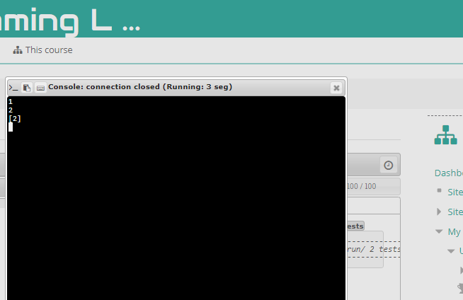

**RESULT:**

Thus the program is executed successfully